# Safety planning

|  |  |
| --- | --- |
| Project leader (Professor) |  |
| Project location (room, building) |  |
| Project title |  |

|  |  |  |
| --- | --- | --- |
| **Name (students/employees)** | **Role in project** | **Training** |
|  |  |  |
|  |  |  |
|  |  |  |
|  |  |  |

# Project description:

|  |
| --- |
|  |

# Hazard analysis and risk assessment

## Chemical hazard identification *(list all chemicals used and hazards associated)*

|  |  |  |
| --- | --- | --- |
| **Chemicals** | **Hazards**  **(skin/ eyes exposition, inhalation, ingestion)** | **Safety measures (risk mitigation)** |
|  |  |  |
|  |  |  |
|  |  |  |
|  |  |  |
|  |  |  |
|  |  |  |
|  |  |  |

# * How to evaluate and apply safety measures:

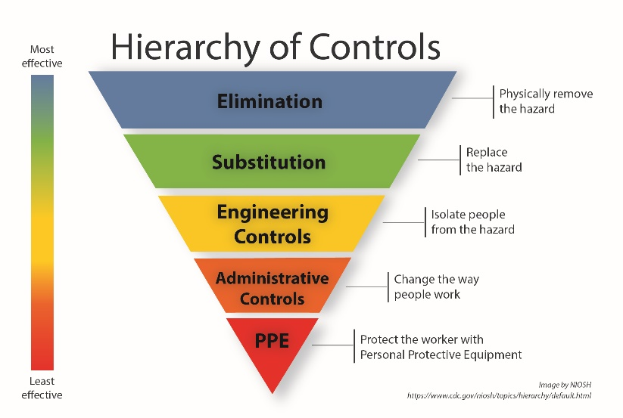

|  |  |
| --- | --- |
| Is it possible to reduce or eliminate the hazard? |  |
| Is it possible to replace the hazard with a less toxic or dangerous solution? |  |
| Do you have engineering controls (ex: chemical hood, ventilation, detector, etc) |  |
| Administrative controls: Do you have specific training, written procedure) |  |
| Personal protective equipment |  |

## Process hazard *(list all hazards associated to the process ex: leak, fire, electric, projection, etc)*

|  |  |  |
| --- | --- | --- |
| **Task** | **Hazards** | **Security measures (risk mitigation) \*** |
|  |  |  |
|  |  |  |
|  |  |  |
|  |  |  |
|  |  |  |
|  |  |  |
|  |  |  |

**Attach all relevant documents (safety datasheets, UQTR’s standard operational procedures, protocols, pictures, etc.)**